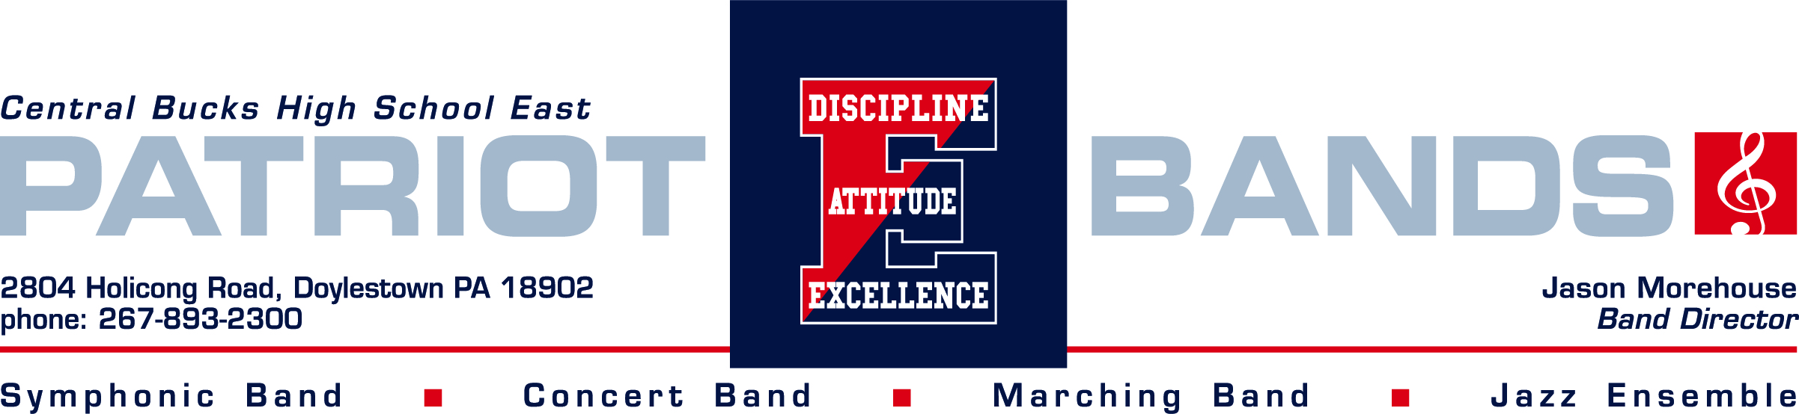Dear Business Owner:

The Central Bucks High School East Band Parents Association and this year’s student musicians invite you to join our exciting 2021-22 season by becoming an advertising sponsor in our concert program.

Under the direction of Jason Morehouse, the CB East Marching Patriots are continuing their tradition of excellence. After an unconventional year with COVID-19 we are hoping to get back to something that resembles a traditional schedule. This fall, in addition to performing at all CB East football games, the band is anticipating performing at several area competitions. The Symphonic Band, Concert Band and Jazz Ensemble continue to achieve superior ratings in PA Music Educators Association adjudications.

Your program ad supports all the CB East bands, and enables the Band Parents Association to fund purchases such as uniforms, instruments, and additional marching band staff.

Your advertisement will be placed in all three of our concert programs throughout the year and will be seen by hundreds of attendees. Additionally, we will promote your business on the band website and in our weekly parent newsletter with a link that allows our members to visit your business website directly. Your ad purchase is a tax-deductible contribution to the CB East Band Parents Association.

We know that this is going to be another great year in the music program at Central Bucks HS East. We hope that you’ll consider coming out to one of our many productions and know that you had a special hand in contributing to the achievements of our talented students.

We look forward to partnering with you in the success of this vibrant community organization!

Sincerely,

Central Bucks HS East Band Parents Association